**Programming Assignment #4**

1. **Code Explanation (Step 1 ~ 8)**

**AddressTranslator.java**

First, the Text File(InputFile.txt) is received through Scanner. Then create TLP, PageTable, Physical Memory, and BackStore.

The size of logical memory and physical memory are same. Therefor, you should divide logical address as 65536(=2^16).

Set the logical address variable addr as addr%65536. The variable of p_num is page number. The size of page number is 8 bytes, therefore, p_num is set as addr/256. Also, offset size is 8 bytes, therefore, offset variable is set as addr%256.

In order to change a logical address to a physical address, the following process is performed.

First, check the page number on the TLB. If it is in TLB, take the frame number from TLB. However, if not, a TLB miss occurs. In this case, go to the page table and check again. However, in this case, if not, page fault occurs. In the next, go to the BackStore and bring the frame number.

The reason for using TLB is that it is more efficient and faster than the page table.

The next figures show the whole process.

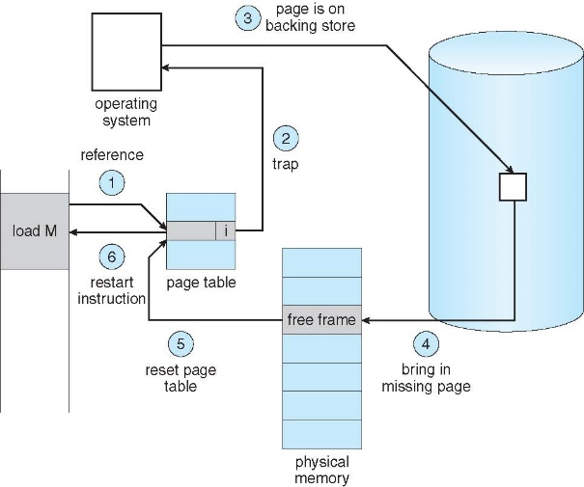

1. check TLB.
   1. If TLB hit, then bring frame number to physical memory.
2. If TLB miss, check page table and bring frame number to physical memory.
3. If page fault, check Backing Store
4. Bring missing page to physical memory
5. Then reset page table and TLB.

**PageTable.java**

Set the initial value to 1 using the constructor. Check the page table in AddressTranslator.java, and if the value is -1, page fault occurs, and check the BackStore to bring the frame number to the page table.

Method get is return the frame number

Method add is add f_num(frame number) to page table.

PageTableItem is the frame number and Boolean that whether it is valid or not.

**TLB.java**

There are 16 entries in the TLB, so 16 cases can be executed fast than using page table. and if the entries are full, we delete the oldest data in TLB and insert new data.

It uses Hashtable to match page number and frame number.

Method put: there are queue and through queue, delete the oldest data and insert the new data.

Method get: if there is page number, you can get relevant frame number.

**BackStore.java**

Through seek function, you can use file pointer, and can get 256 values. And copy to result array and return result.

**PhysicalMemory.java**

There are 256 frames in physical memory.

Method add: new frame is made with f.data and this is added to frames array.

Method get: return data value of frame which is same with f_num.

1. **Step 9**
   1. Input

* You can select Algorithm FIFO or LRU
* The physical memory size is 128.
* Change the PhysicalMemory constructor(using parameter that size of physical memory)
  1. FIFO

Figure . FIFO class

Figure . AddressTranslator

* To implement FIFO algorithm, I made a FIFO class that extends PhysicalMemory.
* The same method is used until the physical memory is full, and the FIFO algorithm is used when choosing a victim.
* We use pointers to pick victims.
* The frame number is obtained through addFrame.
* Deletes the value associated with the victim from the page table.
* Add new values to the page table and TLB.
* In original methods, errors occur after the physical memory is full.
  1. LRU

* To implement LRU algorithm, I made a LRU class that extends PhysicalMemory.
* Use Linked List to implement LRU algorithms.
* Create a Victim method to select a victim.
* add: When the page number is first, it is added to the Linked List in order.
* poll: you can choose the victim and get the oldest page number in the poll() method.
* If b is false, just add and update the Liked List. The return value does not mean anything.
* If b is false, add and update Liked List. Then, the Find Victim return value in the Linked List is the victim page number.
* If the same page number is in the Linked List, use it in the loop to update. Otherwise, add it to the Linked List. Use flag variables to classify the two steps.
  1. Result

Figure 3. FIFO result

Figure . LRU result

Theoretically, LRU shows better performance than FIFO. However, there is no significant difference in the results. Rather, LRUs seem to be creating more page faults.